Industrial A5S Sensor with AOC(4-20mA)-AOV(0-10v) Datasheet
1. Product Overview
WIN-SN-A5S-AOC-AOV is a versatile data acquisition device designed for real-time monitoring in industrial applications, especially ducts. It features precise sensors as detailed, and provides analog output options of 10-bit and 12-bit resolution, ranging from 0 to 10V or 4-20mA. The board's low power consumption and wide operating temperature range make it suitable for numerous applications, such as outdoor air quality monitoring, climate control in greenhouses, and environmental monitoring systems.
Its robust design makes it suitable for installations in HVAC systems, environmental monitoring, and process control. With configurable data sampling rates, multi-sensor compatibility, and easy configuration, WIN-SN-A5S-AOC-AOV ensures accurate Sensor (CH4/H2S/CO2/CO/NH3/PH3) data acquisition and reliable performance in demanding industrial environments, making it an excellent choice for industrial and IOT applications.
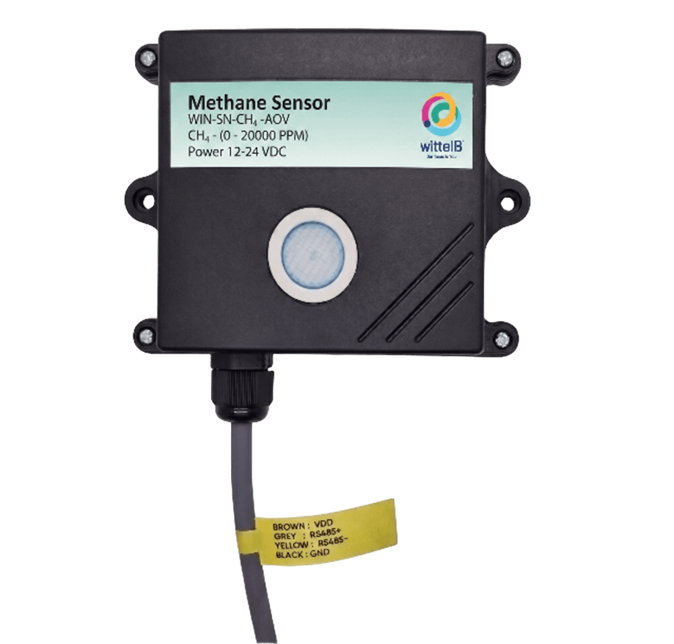

Ex: - Product Image

Sensor Parameters
 | SN | Sensor Name | Measuring Parameter | Measuring Range | Output | Operating Temperature
☐ | a | A-5S-CO | CO | 0-1000 ppm | AOC/AOV | -20°C to +50°C
☒ | b | A-5S-CO2 | CO2 | 0-5000/ 10000/ 40000 ppm | AOC/AOV | -20°C to +50°C
☐ | c | A-5S-NH3 | NH3 | 0-100 ppm | AOC/AOV | -20°C to +50°C
☐ | d | A-5S-PH3 | PH3 | 0-1000 ppm | AOC/AOV | -20°C to +50°C
☐ | e | A-5S-CH4 | CH4 | 0-10000/ 20000 ppm | AOC/AOV | -20°C to +50°C
☐ | f | A-5S-H2S | H2S | 0-100 ppm | AOC/AOV | -20°C to +50°C

 | Product Configuration
☒ | A5S+AO+C
☐ | A5S+AO+V

2. Technical Parameters
- CO Sensor
- Target Gas: Carbon Monoxide(CO)
- Detection Range: 0 to 1000ppm
- Accuracy: ±1 ppm or ±1%
- Detection Accuracy: ~90%
- Technology: Non-Dispersive Infrared (NDIR)
- Response Time: Less than 3 seconds

- CO2 Sensor
- Target Gas: Carbon Dioxide (CO2)
- Detection Range: 0 to 5000/10000/40000 ppm
- Accuracy: ±1 ppm or ±1%
- Detection Accuracy: ~90%
- Technology: Non-Dispersive Infrared (NDIR)
- Response Time: Less than 3 seconds
- NH3 Sensor
- Target Gas: Ammonia (NH₃)
- Detection Range: 0 to 100ppm
- Accuracy: ±1 ppm or ±1%
- Detection Accuracy: ~90%
- Technology: Non-Dispersive Infrared (NDIR)
- Response Time: Less than 3 seconds

- PH3 Sensor
- Target Gas: Phosphine (PH₃)
- Detection Range: 0 to 1000ppm
- Accuracy: ±1 ppm or ±1%
- Detection Accuracy: ~90%
- Technology: Non-Dispersive Infrared (NDIR)
- Response Time: Less than 3 seconds

- CH4 Sensor
- Target Gas: Methane (CH4)
- Detection Range: 0 to 10000/20000 ppm
- Accuracy: ±50 ppm or ±1%
- Detection Accuracy: ~90%
- Technology: Non-Dispersive Infrared (NDIR)
- Response Time: Less than 3 seconds

- H2S Sensor
- Target Gas: Hydrogen Sulfide (H2S)
- Detection Range: 0 to 100 ppm
- Accuracy: ±1 ppm or ±1%
- Detection Accuracy: ~90%
- Technology: Non-Dispersive Infrared (NDIR)
- Response Time: Less than 3 seconds

Note: All sensors require a 90-second warm-up period after power-on to provide accurate measurements.
2. Sensor Specifications
- Wide temperature range: −40 °C to +125 °C
- Full humidity range: 0 % to 100 % RH
- Power supply DC: 12-24V@1A.
- Product dimension: 85*85*36 mm.

- Certifications:

3. Power Supply Connection
DC Connection
- Use 12-24V@ 1A, Power supply.
- Don’t make loose connection.

5. Recommended Cable Electrical Characteristics
22 AWG Cable Shielded and twisted pair should be used.
Tinned Copper Recommended
Nominal Conductor DCR 14.7 ohm / 1000 ft
Nominal Capacitance 11 pf / feet (conductor to conductor)
High Frequency Non-Insertion Loss 0.5db / 100ft

Recommended Cable Electrical Characteristics
- Read all instructions before using the sensor board
- Keep the sensor board away from water or moisture to prevent damage.
- Do not disassemble or modify the sensor board.
- Use only the specified power sources and mentioned.

6. Analog Output AOC/AOV Specifications
- Measured Parameters: A5S sensor.
- Output Type: Analog Output-10-bit and 12-bit resolution.
- Output Range: AOV 0-10V / AOC 4-20mA.
- Wide temperature range: −20 °C to +85 °C.
- Full humidity range: 0 % to 100 % RH
- Product dimension: 85*85*40 mm.
- Power supply DC: 12-24V DC @1A (Type –C power USB).


- Certifications:

Contact Information
Augmatic Technologies Pvt. Ltd.,
Plot no 6, Shah Industrial Estate II,
Kotambi,
Vadodara – 391510.
Email – Sales@wittelb.com
Support: support@wittelb.raiseaticket.com / +91 94038 92805

